**GP Out of Hours Service – Frequently Asked Questions**

**Updated FAQs – January 2025**

1. **Why is the GP Out of Hours Service re-procurement exercise taking place, and why now?**

As part of NHS Shropshire, Telford and Wrekin’s commissioning responsibilities, there is a need to re-procure the GP Out of Hours Service in line with statutory and legal duties. The exercise is also part of our usual business cycle as a commissioning organisation.

From the 1 January 2024, the Provider Selection Regime (PSR) came into force and set a specific number of rules for procuring healthcare services in England. The PSR was introduced by regulations made under the Health and Care Act 2022 which you can read more about at: [NHS England » The Provider Selection Regime: statutory guidance](https://www.england.nhs.uk/long-read/the-provider-selection-regime-statutory-guidance/).

As a result of this, we have had to undertake an exercise to look at all contracts due to end in 2024-25 and to assess which procurement process can be used for each individual service using the legislative framework. These services included the GP Out of Hours provision, the Care Coordination Centre Single Point of Access (CCCSPA) service, Outbreaks Response and cover for Protected Learning Time (PLT) in General Practice.

1. **Why has NHS Shropshire, Telford and Wrekin decided to go down a competitive procurement route rather than awarding the contract on a ‘most suitable provider’ basis?**

Due to changes in national regulations, as referenced above, NHS STW has agreed to review the current service specification for the GP Out of Hours Service, with a priority to ensuring minimum changes to the current service provided.

As an organisation, in conjunction with our procurement advisors, we reviewed all the options available to us in procuring these services. We were aware of other providers in this market and were unable to determine who the most suitable provider might be without understanding what these other providers were able to offer.

We therefore used a competitive process to ensure that we were able to identify the best quality and value for money service provision for the population of Shropshire, Telford and Wrekin, in accordance with the principles of the Provider Selection Regime (PSR). A competitive procurement means that, as a healthcare commissioning organisation, we continue to provide a high-quality GP Out of Hours Service that meets the needs of our local people.

1. **Is this a money-saving exercise? Will NHS Shropshire, Telford and Wrekin prioritise local knowledge, experience and relationships above cost?**

We are clear in our intention to prioritise as little impact as possible to our patients and residents, and to ensure we are providing the very best service we can. Much of our work is based on the existing specification for the GP Out of Hours Service and focuses on continued good access for patients. You can view [the service specification for the GP Out of Hours Service here](https://www.shropshiretelfordandwrekin.nhs.uk/wp-content/uploads/GP-OOH-Local-Service-Spec-FINAL.pdf).

We have always been clear that the decision to go out to procurement was driven by legislation in this area, given the size and duration of the contract. It was therefore not a financial decision, and the procurement is not a cost cutting exercise but is about ensuring value for money alongside high-quality service provision, whilst meeting legislative obligations within the Provider Selection Regime (PSR).

1. **How can you ensure this is in the best interest of patients, and how have people been involved in this process?**

All providers who submit a bid for the new contract will be required to demonstrate how they will achieve certain requirements and criteria. This will be evaluated by a range of individuals from both within and outside of NHS STW, based on providers’ answers to these questions.

As part of this process, we have also collected a broad range of patient feedback via a public survey to help us to understand people’s views around GP Out of Hours services and what is important to them. This enables us to enact our role as a health commissioning organisation to provide the very best service we can for the people of this county, and to ensure we are acting in line with procurement regulations. We have also had several patients contribute to this process and there will be a patient representative present on the bidder interview panel.

Once the contract is up and running, a greater level of performance monitoring will be in place to ensure that the requirements outlined in the service specification (such as response times, patient experience and the impact on other services like A&E) continue to be met.

1. **When can we expect an outcome from the re-procurement exercise?**

Following a robust evaluation process concluding in December 2024, the outcomes from these exercises will go through NHS STW governance and due diligence processes in January 2025.

We are then hopeful that approval to award the contract will be made in a closed board meeting due to the requirement for confidentiality, followed by a ‘standstill period’ as part of the PSR process. Please see below for further details on the standstill period and possible representation process.

Until this process has concluded, NHS STW will not be able to confirm the outcome as we will remain in a live procurement exercise and are bound by the legalities that surround this.

***Standstill period and representation process:***

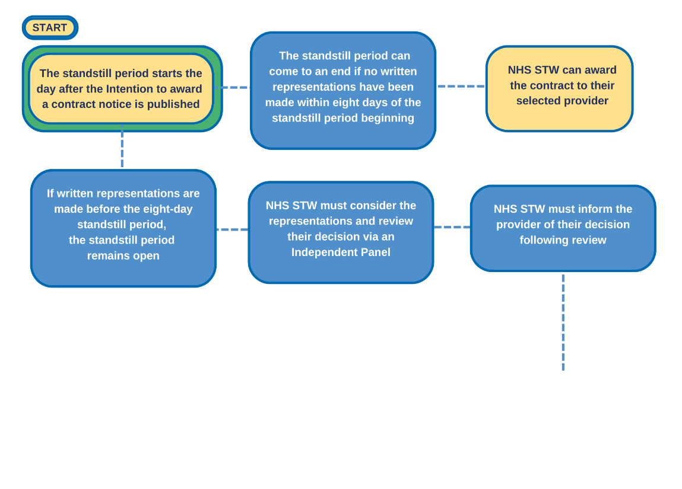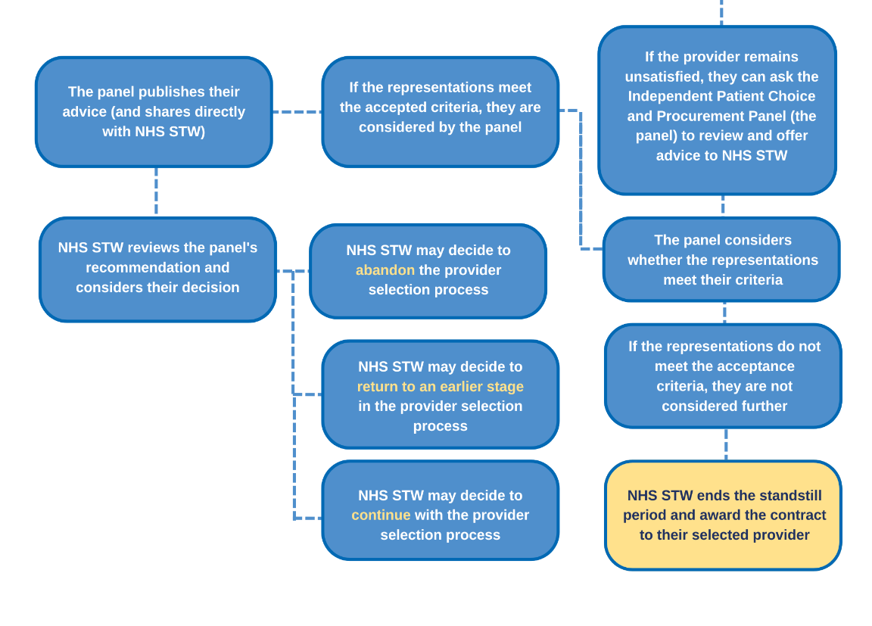

1. **Will a new provider change the current service?**

As part of the service specification for the GP Out of Hours Service, a priority for NHS STW has been to ensure as little impact and change to patients as possible. The service specification outlines what is important for local residents in relation to this service, and also describes the requirement for integration, collaboration and relationships with other services and providers across Shropshire, Telford and Wrekin and neighbouring areas.

All providers who submit a bid for the new contract will be required to demonstrate comprehensively how they will ensure these requirements are met, their experience of delivering similar services and achieving the required outcomes, and how they would achieve continuity of care during the transition process. Providers may have their own ideas as to how service delivery could be improved, and we will work with the successful provider to implement positive changes, where appropriate.

1. **Has NHS STW considered the impact on the quality of palliative and end-of-life care if a new provider is selected?**

The service specification is clear that there will be no change to the palliative care line and that home visits will continue to be available and, as such, there will be no changes to access. The re-procurement also allows providers to explore innovative access options which will offer further opportunities for ease of access.

The service specification for the GP Out of Hours Service can be found on the [NHS Shropshire, Telford and Wrekin website, here](https://www.shropshiretelfordandwrekin.nhs.uk/wp-content/uploads/GP-OOH-Local-Service-Spec-FINAL.pdf).

**General FAQs**

**1. Can I contact the GP Out of Hours Service directly, rather than via 111?**

Unfortunately, this is not something we are able to change. The NHS 111 service changed in 2018 to become a single point of access for urgent healthcare services across Shropshire, Telford and Wrekin. This is a national requirement, so we are unable to put alternative arrangements in place locally.

**2. Why do I have to travel for a GP Out of Hours appointment?**

The GP Out of Hours Service is designed for urgent health needs which can’t wait until the next day your local GP practice is open. This means that the service has to cover the whole of Shropshire, Telford and Wrekin overnight and on weekends/bank holidays and it would not be practical to have face to face appointments available in every local area. Appointments are available at several locations across the county, and we will continue to work with the provider under the new contract to ensure an equitable spread of bases to meet the needs of the local population.

**3. Can I see a GP at my own practice outside of normal hours?**

This is an urgent care service for health concerns which can’t wait until your own GP practice is open again. There are currently 50 GP practices across the county, so it wouldn’t be practical or safe to have clinicians available at each practice during every out of hours period.

**4. Why have I been advised to contact my own GP the next time they are open, rather than being seen by someone out of hours?**

This service is available for urgent health needs outside of normal General Practice hours but there may be occasions where a need that feels urgent could wait until your normal GP practice is open. The GP Out of Hours provider will triage all calls and decide which are urgent and need to be seen quickly, and which are not as urgent and could wait until the following day.

The triage process is also used to assess how quickly someone receives a callback during the out of hours period. This is why it is often not possible to call everybody back within a short timescale, and why there may be a delay in you receiving a call back. We appreciate that it can be worrying when you or your loved ones are ill, but please be assured that calls are returned in priority order to ensure the most urgent cases are dealt with in a timely manner.

**5. Can the Out of Hours GP come and see me at home?**

Home visits are available for those people who are unable to leave their home to seek help, but the service covers a large, mostly rural area. The majority of appointments are offered in local bases across the county so that the GP Out of Hours clinicians are able to see and treat more people face to face.

**6. Will the service provider for the new contract have a knowledge of the local area and the services available locally?**

The service specification outlines the value of this aspect of the service for local residents, and also describes the requirement for integration, collaboration and relationships with other services and providers across Shropshire, Telford and Wrekin and neighbouring areas. All providers who submit a bid for the new contract will be required to demonstrate how they would ensure these requirements are met, their experience of delivering similar services and achieving the required outcomes, and how they would achieve continuity of care during the transition process.

**7. How will you ensure that the level of service under the new contract is the same (or better) than the current service?**

All providers who submit a bid for the new contract will be required to demonstrate how they will achieve certain requirements and criteria, and this will be evaluated based on their answers to these questions. Once the contract is up and running, a greater level of performance monitoring will be in place to ensure that the requirements outlined in the service specification (such as response times, patient experience and the impact on other services like A&E) continue to be met. Improvement plans will also be implemented to manage performance, where they are required.

**ENDS**