Thunderclap June 2024 - SOCIAL MEDIA FOR THE OPEN UP CAMPAIGN
Monday 10 June -
Post 1 – Time: 6am
Post 2 – Time: 1pm
Post 3 - Time: 7pm
Image | X | Facebook / LinkedIn
Post 1  Sophie Video - Parents  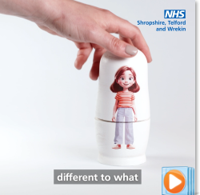 | To mark #LonelinessAwarenessWeek 2024, @NHSSTW has launched a new initiative to address #loneliness among children in the region.  There are lots of ways you can help your child tackle loneliness and encourage connection and well-being: ➡️ https://www.shropshiretelfordandwrekin.nhs.uk/news/open-up-campaign-launched-to-help-prevent-loneliness-in-children | To mark #LonelinessAwarenessWeek 2024, @NHSSTW has launched a new initiative to address #loneliness among children in the region.  The 'Open Up' campaign seeks to raise awareness about the signs of loneliness and provide practical guidance and support to parents, carers, and children on how to prevent and combat #loneliness.  There are lots of ways you can help your child tackle loneliness and encourage connection and well-being: ➡️ https://www.shropshiretelfordandwrekin.nhs.uk/news/open-up-campaign-launched-to-help-prevent-loneliness-in-children
Post 2  Lucas Static - Parents  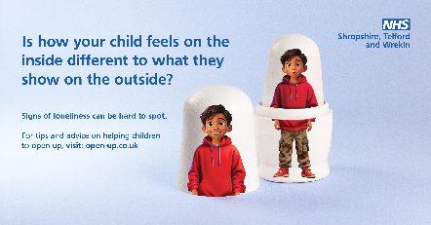 | Signs of #loneliness can be hard to spot as young people struggle to #OpenUp about how they’re feeling 😔  Find out more about the signs of loneliness and how you can help a child open up this #LonelinessAwarenessWeek ➡️ open-up.co.uk | Signs of #loneliness can be hard to spot as young people struggle to #OpenUp about how they’re feeling 😔  Find out more about the signs of loneliness and how you can help a child open up this #LonelinessAwarenessWeek ➡️ open-up.co.uk
Post 3  Zara Video - Parents  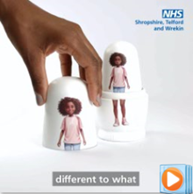 | A child may appear happy on the outside 😃 when, on the inside, they feel lonely 😟  This #LonelinessAwarenessWeek, find out more about how you can help a to #OpenUp ➡️ open-up.co.uk | A child may appear happy on the outside 😃 when, on the inside, they feel lonely 😟  This #LonelinessAwarenessWeek, find out more about how you can help a to #OpenUp ➡️ open-up.co.uk
Tuesday 11 June 2024
Time: 6 am
Zara Static - Parents  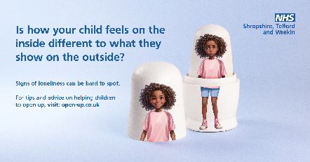 | 1 in 9 young people sometimes feel lonely. Signs of #loneliness can be hard to spot 😕  This #LonelinessAwarenessWeek, find out more about the signs of loneliness and how you can help a child #OpenUp ➡️ open-up.co.uk | 1 in 9 young people sometimes feel lonely. Signs of #loneliness can be hard to spot 😕  This #LonelinessAwarenessWeek, find out more about the signs of loneliness and how you can help a child #OpenUp ➡️ open-up.co.uk
Wednesday 12 June 2024
Time: 7pm
William Video – Parents  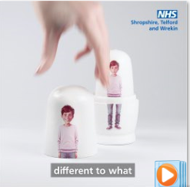 | Signs of #loneliness can be hard to spot as young people struggle to #OpenUp about how they’re feeling.  Signs of loneliness can include:  😔Lack of social connection  🥺Low mood and lack of interest  Find out how to spot the signs of loneliness in children ➡️ open-up.co.uk | Signs of #loneliness can be hard to spot as young people struggle to #OpenUp about how they’re feeling.  Signs of loneliness can include:  😔Lack of social connection  🥺Low mood and lack of interest  Find out how to spot the signs of loneliness in children ➡️ open-up.co.uk
Thursday 13 June 2024
Time: 4pm
Sophie Static - Parents  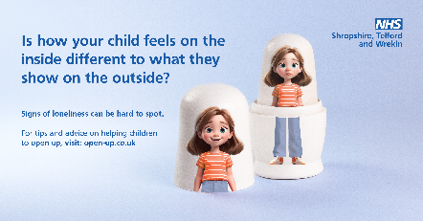 | A child may appear happy on the outside 😃 when, on the inside, they feel #lonely 😟  This #LonelinessAwarenessWeek, find out more about the signs of loneliness and how you can help a child #OpenUp ➡️ open-up.co.uk | A child may appear happy on the outside 😃 when, on the inside, they feel #lonely 😟  This #LonelinessAwarenessWeek, find out more about the signs of loneliness and how you can help a child #OpenUp ➡️ open-up.co.uk
Friday 14 June 2024
Time: 6am
Lucas Video - Parents  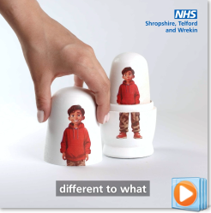 | This week is #LonelinessAwarenessWeek. It can be hard to talk about feeling lonely, children & young people might not want to say they don’t have friends or feel left out 👪  Find out more about the signs of loneliness & how you can help a child #OpenUp ➡️ open-up.co.uk | This week is #LonelinessAwarenessWeek. It can be hard to talk about feeling lonely, children and young people might not want to say that they don’t have friends or feel left out 👪  Find out more about the signs of loneliness and how you can help a child #OpenUp ➡️ open-up.co.uk
Saturday 15 June 2024
Time: 6pm
Williams Static - Parents  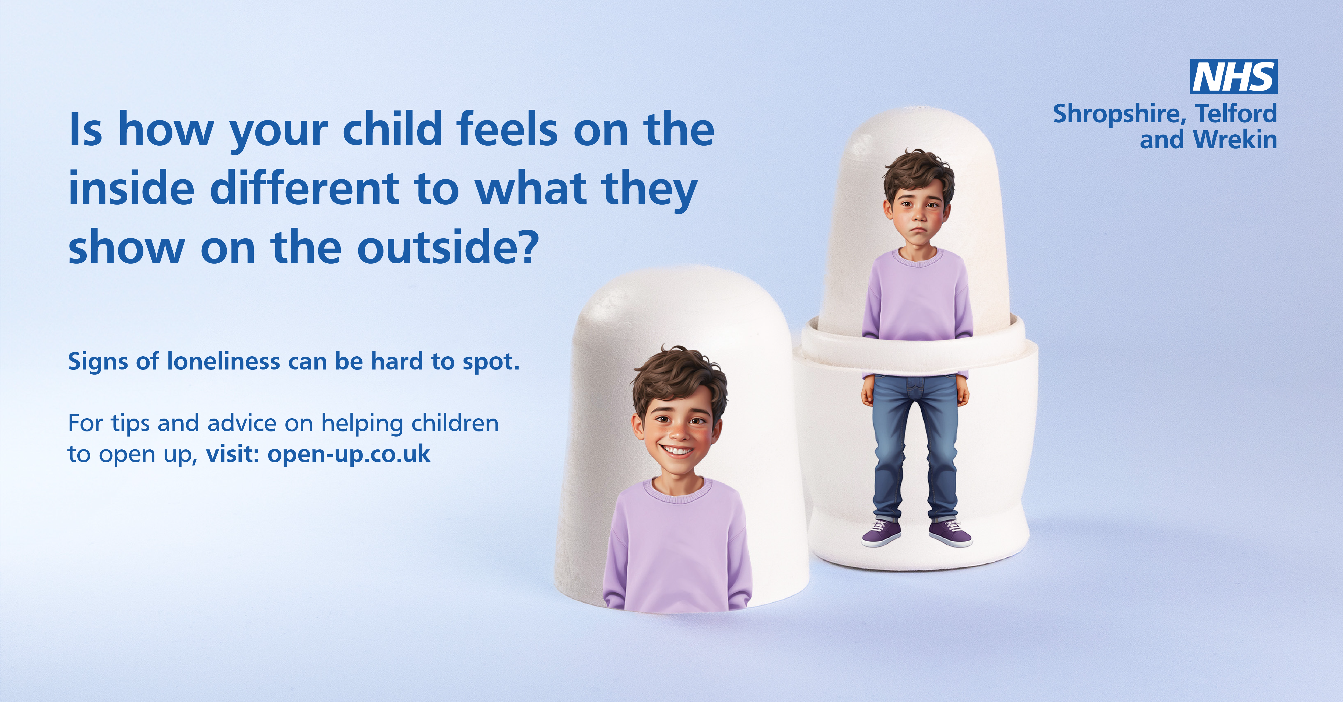 | This week is #LonelinessAwarenessWeek. A child choosing to be by themselves or enjoying their own company is different to loneliness.  ❗ It’s important to know what to look out for and where to go to seek help. Find out more ➡️ open-up.co.uk | This week is #LonelinessAwarenessWeek. A child choosing to be by themselves or enjoying their own company is different to loneliness.  ❗ It’s important to know what to look out for and where to go to seek help. Find out more ➡️ open-up.co.uk
Sunday 16 June 2024
Time: 8am
Zara Video – Parents  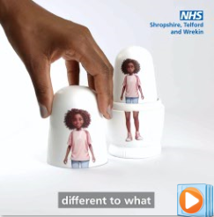 | A child may appear happy on the outside 😃 when, on the inside, they feel #lonely 😟  This #LonelinessAwarenessWeek, find out more about the signs of loneliness and how you can help a child #OpenUp ➡️ open-up.co.uk | A child may appear happy on the outside 😃 when, on the inside, they feel #lonely 😟  This #LonelinessAwarenessWeek, find out more about the signs of loneliness and how you can help a child #OpenUp ➡️ open-up.co.uk

