The concept
What?
The idea behind the thunderclap is everyone posting the same thing at the same time.

Why?
To amplify the ‘Think which service’ campaign messages, increase reach and maximise impact across Shropshire, Telford and Wrekin.

When?
We're inviting all partners to take part during the ‘Think which service‘ launch week: Wednesday 6 November to Tuesday, 12 November 2024 and again February 2025 (date tbc).

How it will work
- A week prior to launch, we will share a ‘Think which service - thunderclap’ social media toolkit. The toolkit will provide agreed social media content, including graphics, hashtags and, importantly, a schedule.

- We are proposing that during the launch week, three nominated time slots will be devoted to the ‘Think which service’ campaign messages each day. During this time we are proposing that x3 social media messages will be issued at the following times 9:03am, 1:03pm and 5:03pm each day.

- For the thunderclap to work, it will be critical that all system comms colleagues schedule the posts on the day and time provided in the schedule. This will maximise the impact.

Wednesday, 6 November 2024 - Launch Day
Time | Image | X (Twitter) copy | Facebook / LinkedIn copy | Instagram
9:05 AM | Think Which Service Video Launch   | Today, we launch our #Winter campaign #ThinkWhichService  Chief Nursing Officer, Vanessa Whatley, shares some of the ways you can look after yourself this winter, and be sure you access the right services.  ➡️️ www.thinkwhichservice.co.uk  #NHSSTW #NHS #Pharmacy #NHS111 #SelfCare | Today, we launch our #Winter campaign #ThinkWhichService  Chief Nursing Officer, Vanessa Whatley, shares some of the ways you can look after yourself and others this winter, and access the right services, for the right help, fast.  Click here for more information➡️️ www.thinkwhichservice.co.uk  #ThinkWhichService #NHSSTW #NHS #Pharmacy #NHS111 #SelfCare | Today, we launch our #Winter campaign #ThinkWhichService  Chief Nursing Officer, Vanessa Whatley, shares some of the ways you can look after yourself and others this winter, and access the right services, for the right help, fast.  #ThinkWhichService #NHSSTW #NHS #Pharmacy #NHS111 #SelfCare
1:05 PM | Motion video scarf Nov 24  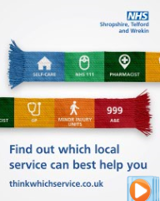 | This winter, we’re back with an updated guide to help you ‘Think Which Service’ for the best care possible. By choosing the right service, you’ll get the advice, support, and treatment you need even faster ➡️️ www.thinkwhichservice.co.uk #NHSSTW #NHS #ThinkWhichService | When you need help, it’s important to know which service best suits your needs.  This winter, we’re back with an updated guide to help you ‘Think Which Service’ for the best care possible.  By choosing the right service, you’ll get the advice, support, and treatment you need even faster—so you can feel your best all season long.  ➡️ www.thinkwhichservice.co.uk  #NHSSTW #NHS #Pharmacy #NHS111 #SelfCare #Winter #ThinkWhichService | When you need help, it’s important to know which service best suits your needs.  This winter, we’re back with an updated guide to help you ‘Think Which Service’ for the best care possible.  By choosing the right service, you’ll get the advice, support, and treatment you need even faster—so you can feel your best all season long.  #NHSSTW #NHS #Pharmacy #NHS111 #SelfCare #Winter #ThinkWhichService
5:05 PM | Think Which Service Scarf Graphic Landscape  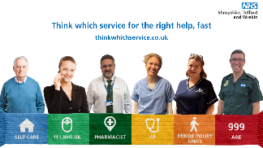 | When it comes to your health, choosing the right service can make a big difference. Whether it’s a minor ailment, mental health concern or a more serious issue, knowing where to go is essential. 🏥 Visit ➡️️ www.thinkwhichservice.co.uk #ThinkWhichService #NHSSTW #NHS | When it comes to your health, choosing the right service can make all the difference.  Whether it’s a minor ailment, a mental health concern or a more serious issue, knowing where to go is essential. 🏥  NHS 111 if you are not sure what to do  💊 Pharmacies for minor ailments  👨‍⚕️ GPs for ongoing issues  🤕 MIUs for minor injuries  🚑 Emergency services for life-threatening situations  Make informed choices and ensure you receive the right care, at the right time!  For more information visit ➡️️ www.thinkwhichservice.co.uk #ThinkWhichService #NHSSTW #NHS #Pharmacy #NHS111 #SelfCare #Winter | When it comes to your health, choosing the right service can make all the difference.  Whether it’s a minor ailment, a mental health concern or a more serious issue, knowing where to go is essential. 🏥  NHS 111 if you are not sure what to do  💊 Pharmacies for minor ailments  👨‍⚕️ GPs for ongoing issues  🤕 MIUs for minor injuries  🚑 Emergency services for life-threatening situations  Make informed choices and ensure you receive the right care, at the right time!  #ThinkWhichService #NHSSTW #NHS #Pharmacy #NHS111 #SelfCare #Winter
Thursday, 7 November – Self-care
Time | Image | X (Twitter) copy | Facebook / LinkedIn copy | Instagram
9:05 am | Think Which Service Video Self Care  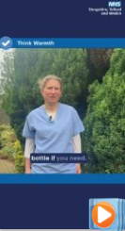 | Self-care is the first step to keeping yourself well this #Winter Dr Jess Harvey, local GP, explains some of the ways you can look after your health this winter ❄  For more information visit ➡️️ www.thinkwhichservice.co.uk  #ThinkWhichService #NHSSTW #NHS #SelfCare #LocalGP | Think self-care this winter.  Self-care is the first step to keeping yourself well this #Winter  Dr Jess Harvey, local GP, explains some of the ways you can look after your health this winter ❄  For more information visit ➡️️ www.thinkwhichservice.co.uk  #ThinkWhichService #NHSSTW #NHS #SelfCare | Think self-care this winter.  Self-care is the first step to keeping yourself well this #Winter  Dr Jess Harvey, local GP, explains some of the ways you can look after your health this winter ❄  #ThinkWhichService #NHSSTW #NHS #SelfCare
1:05 pm | Think Which Service Static Image  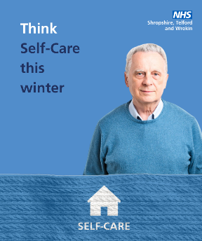 | Winter can bring a variety of health challenges, from colds and flu to minor injuries. Having a well-stocked medicine cabinet can help you manage these issues effectively 💊 More information➡️️ www.thinkwhichservice.co.uk #ThinkWhichService #NHSSTW #NHS #Winter #SelfCare #Medicines | Winter can bring a variety of health challenges, from colds and flu to minor injuries.  Having a well-stocked medicine cabinet can help you manage these issues effectively  Think self-care this winter.  For more information visit ➡️️ www.thinkwhichservice.co.uk  #ThinkWhichService #NHSSTW #NHS #Winter #SelfCare #Medicines | Winter can bring a variety of health challenges, from colds and flu to minor injuries.  Having a well-stocked medicine cabinet can help you manage these issues effectively 💊  Think self-care this winter.  #ThinkWhichService #NHSSTW #NHS #Winter #SelfCare #Medicines
5:05 pm | Vaccine static  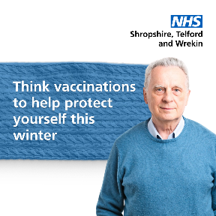 | During the winter #Flu #COVID19 and #RSV cases are likely to increase. Protect you and your loved ones by getting your vaccinations 💉 if you’re eligible For more information visit ➡️️ www.thinkwhichservice.co.uk #ThinkWhichService #Vaccinations #WinterVaccinations #NHSSTW | Think vaccination to help protect yourself this winter.  During the winter #Flu #COVID19 and #RSV cases are likely to increase.  Protect you and your loved ones from becoming seriously unwell by getting your vaccinations 💉 if you’re eligible  For more information visit ➡️️ www.thinkwhichservice.co.uk  #ThinkWhichService #Vaccinations #WinterVaccinations #NHSSTW | Think vaccination to help protect yourself this winter.  During the winter #Flu #COVID19 and #RSV cases are likely to increase.  Protect you and your loved ones from becoming seriously unwell by getting your vaccinations 💉 if you’re eligible  #ThinkWhichService #Vaccinations #WinterVaccinations #NHSSTW

Friday, 8 November 2024 – 111.nhs.uk
Time | Image | X (Twitter) copy | Facebook / LinkedIn copy | Instagram
9:05 am | Think Which Service Video NHS 111  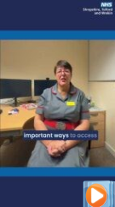 | Worried about symptoms or need help with an injury? Think www.111.nhs.uk 💻 where you can answer some questions and get instant advice. You can also dial 111 📞 for the same support 🤝 #ThinkWhichService #NHSSTW #NHS #Winter #NHS111 #NHS111Online | Worried about symptoms or need help with an injury?  Think www.111.nhs.uk 💻 to answer some questions and receive instant advice on what to do or the best place to go.  You can also dial 111 for the same support  Help us to keep #GP appointments and A&E free for those who need them most.  #ThinkWhichService #NHSSTW #NHS #Winter #NHS111 #NHS111Online | Worried about symptoms or need help with an injury?  Think www.111.nhs.uk 💻 to answer some questions and receive instant advice on what to do or the best place to go.  You can also dial 111 for the same support  Help us to keep #GP appointments and A&E free for those who need them most.  #ThinkWhichService #NHSSTW #NHS #Winter  #NHS111 #NHS111Online
1:05 pm | Think Which Service Static Image 111  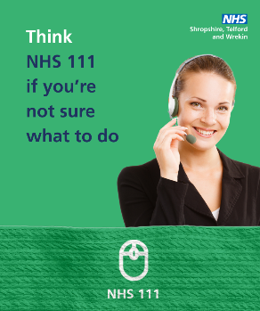 | Need advice this winter? Think NHS 111! NHS 111 is available online or by phone and can help you check symptoms, provide dental advice, and offer information on prescriptions and medicines. Visit ➡️️www.thinkwhichservice.co.uk #ThinkWhichService #NHSSTW | Need advice this winter? Think NHS 111!  NHS 111 is available online or by phone and can help you check symptoms, provide dental advice, and offer information on prescriptions and medicines, helping to keep A&E available for those in urgent need.  For more information visit ➡️️www.thinkwhichservice.co.uk  #ThinkWhichService #NHSSTW #NHS #Winter #NHS111 #NHS111Online | Need advice this winter? Think NHS 111!  NHS 111 is available online or by phone and can help you check symptoms, provide dental advice, and offer information on prescriptions and medicines, helping to keep A&E available for those in urgent need.  #ThinkWhichService #NHSSTW #NHS #Winter #NHS111 #NHS111Online
5:05 PM | Charlie 1-4  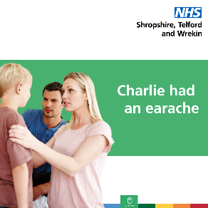 | We know it’s distressing when your little one isn’t well. NHS 111 is a fast way to get treated by the right service, without the wait times, in the comfort of your own home 🏠 🤒 Visit ➡️️www.thinkwhichservice.co.uk #ThinkWhichService #NHSSTW #NHS #NHS111 #NHS111Online | We know it’s distressing when your little one isn’t well. Think NHS 111 if you are not sure what to do.  NHS 111 is a fast way to get treated by the right service, without the wait times and from the comfort of your own home 🏠 🤒  For more information visit ➡️ www.thinkwhichservice.co.uk  #ThinkWhichService #NHSSTW #NHS #Winter #NHS111 #NHS111Online | We know it’s distressing when your little one isn’t well. Think NHS 111 if you are not sure what to do.  NHS 111 is a fast way to get treated by the right service, without the wait times and from the comfort of your own home 🏠 🤒  #ThinkWhichService #NHSSTW #NHS #Winter #NHS111 #NHS111Online

Saturday, 9 November 2024 – Pharmacist
Time | Image | X (Twitter) copy | Facebook / LinkedIn copy | Instagram
9:05 AM | Think Which Winter Video Pharmacy  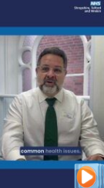 | Think #Pharmacy for day-to-day illnesses and minor health concerns 💊 Local community pharmacist Alex talks about how your pharmacy can give advice and medicines without a GP appointment. Visit ➡️️www.thinkwhichservice.co.uk #ThinkWhichService #NHSSTW #NHS #Pharmacy #Pharmacist | Think #Pharmacy for day-to-day illnesses and minor health concerns 💊  Local community pharmacist Alex talks about how your pharmacy can give advice and medicines without the need for a GP appointment.  For more information visit ➡️️www.thinkwhichservice.co.uk  #ThinkWhichService #NHSSTW #NHS #Winter #Pharmacist #Pharmacy | Think #Pharmacy for day-to-day illnesses and minor health concerns 💊  Local community pharmacist Alex talks about how your pharmacy can give advice and medicines without the need for a GP appointment.  #ThinkWhichService #NHSSTW #NHS #Winter #Pharmacist #Pharmacy
1:05PM | Tia 1-4  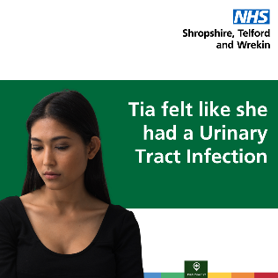 | Before booking a GP appointment think #PharmacyFirst 💊 #Pharmacists are highly trained to assess your symptoms and can usually provide the treatment you need – often without an appointment. Visit ➡️️www.thinkwhichservice.co.uk #ThinkWhichService #NHSSTW #NHS #Winter #Pharmacy | Before booking a GP appointment think #PharmacyFirst 💊  #Pharmacists are highly trained to assess your symptoms and can usually provide the treatment you need – often without an appointment.  For more information visit ➡️️www.thinkwhichservice.co.uk  #ThinkWhichService #NHSSTW #NHS #Winter #Pharmacist #Pharmacy | Before booking a GP appointment think #PharmacyFirst 💊  #Pharmacists are highly trained to assess your symptoms and can usually provide the treatment you need – often without an appointment.  #ThinkWhichService #NHSSTW #NHS #Winter #Pharmacist #Pharmacy
5:05 PM | Think Which Service Static Image Pharmacy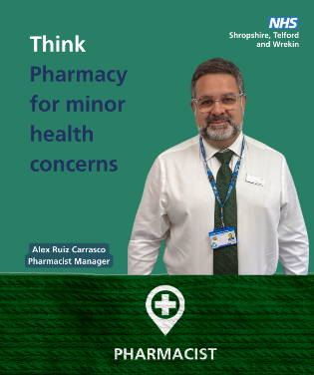 | Need advice? 🤔 Think Pharmacy First You don’t need to wait for a #GP appointment - your local #Pharmacist can help with a range of minor illnesses. For more information visit ➡️️www.thinkwhichservice.co.uk #ThinkWhichService #NHSSTW #NHS #Winter #Pharmacy | Need advice? Think Pharmacy First  You don’t need to wait for a #GP appointment - your local #Pharmacist can help with a range of minor illnesses.  For more information visit ➡️️www.thinkwhichservice.co.uk  #ThinkWhichService #NHSSTW #NHS #Winter #Pharmacy | Need advice? Think Pharmacy First  You don’t need to wait for a #GP appointment - your local #Pharmacist can help with a range of minor illnesses.  #ThinkWhichService #NHSSTW #NHS #Winter #Pharmacy

Sunday, 10 November 2024 - GP
Time | Image | X (Twitter) copy | Facebook / LinkedIn copy | Instagram
9:05 AM | Jamar 1-4  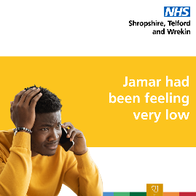 | Did you know? Your GP practice can offer more options than you might think! Discover how extended healthcare teams in GP practices can support you. 💬🙌 For more information visit ➡️️ www.thinkwhichservice.co.uk #ThinkWhichService #NHSSTW #NHS #GP #GPServices #HealthcareTeam | Did you know? GP practices are now working with extended healthcare teams to bring you specialised support.  With professionals like mental health practitioners, pharmacists, and care navigators, these teams are ready to address a wide range of health concerns!  Extended healthcare teams are here to make sure you get the right support when you need it most.  Learn more about the professionals in your local practice and how they can help you on your journey to better health. 💙  For more information visit  ➡️️ www.thinkwhichservice.co.uk  #ThinkWhichService #NHSSTW #NHS #Winter #GP #GPServices #HealthcareTeam | Did you know? GP practices are now working with extended healthcare teams to bring you specialised support.  With professionals like mental health practitioners, pharmacists, and care navigators, these teams are ready to address a wide range of health concerns!  Extended healthcare teams are here to make sure you get the right support when you need it most.  #ThinkWhichService #NHSSTW #NHS #Winter #GP #GPServices #HealthcareTeam
1:05 PM | Think Which Service Static Image GP  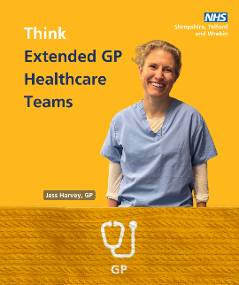 | "Think Which Service" this winter! If you're offered an appointment with a healthcare professional other than a GP, it’s because they’re the best person to support your specific needs. #ThinkWhichService #NHSSTW #NHS #Winter #GP #HealthcareTeam | "Think Which Service" this winter! If you're offered an appointment with a healthcare professional other than a GP, it’s because they’re the best person to support your specific needs.  The extended healthcare team all work closely together to ensure you receive the right care, at the right time, from the right person  For more information visit ➡️️ www.thinkwhichservice.co.uk  #ThinkWhichService #NHSSTW #NHS #Winter #GP #GPServices #HealthcareTeam | "Think Which Service" this winter! If you're offered an appointment with a healthcare professional other than a GP, it’s because they’re the best person to support your specific needs.  The extended healthcare team all work closely together to ensure you receive the right care, at the right time, from the right person  #ThinkWhichService #NHSSTW #NHS #Winter #GP #GPServices #HealthcareTeam
5:05 PM | Think Which Service Video GP Extended Healthcare  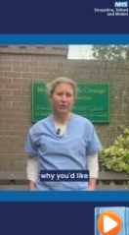 | Extended healthcare teams support patients in #GPSurgeries across the county. Dr Jess Harvey, local #GP, talks about some of the highly skilled and qualified professionals that work alongside GPs. #ThinkWhichService #NHSSTW #NHS #Winter #GPServices #GPTeam | "Think Which Service" when visiting your GP practice! Extended healthcare teams provide support across Shropshire, Telford and Wrekin and include highly skilled professionals working alongside GPs.  Dr. Jess Harvey, local GP, shares insights on how these experts can help you get the right care, from the right person, at the right time.  To find out more ➡www.thinkwhichservice.co.uk  #ThinkWhichService #NHSSTW #NHS #Winter #GP #GPServices #GPSurgery #GPTeam | "Think Which Service" when visiting your GP practice! Extended healthcare teams provide support across Shropshire, Telford and Wrekin and include highly skilled professionals working alongside GPs.  Dr. Jess Harvey, local GP, shares insights on how these experts can help you get the right care, from the right person, at the right time.  To find out more ➡www.thinkwhichservice.co.uk  #ThinkWhichService #NHSSTW #NHS #Winter #GP #GPServices #GPSurgery #GPTeam

Monday, 11 November 2024 – Minor Injury Unit
Time | Image | X (Twitter) copy | Facebook / LinkedIn copy | Instagram
9:05 AM | Think Which Service Video MIU  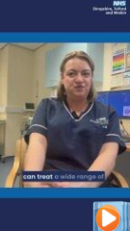 | Think #MinorInjuryUnit (#MIU) before A&E.  ➡ Emergency Nurse Practitioner, Michelle Murray, explains how MIUs are a great option when you have a minor injury that isn't life-threatening.  Visit ➡️️ www.thinkwhichservice.co.uk  #ThinkWhichService #NHSSTW #NHS #Winter #MinorInjuries | Think Minor Injury Units (MIUs) before A&E.  ➡ Emergency Nurse Practitioner, Michelle Murray, explains when to visit an MIU.  MIUs are a great option when you have a minor injury that isn't life-threatening. They can save you time and get you the care you need quickly.  For more information visit ➡️️ www.thinkwhichservice.co.uk  #ThinkWhichService #NHSSTW #NHS #Winter #MIU #MinorInjuries #MinorInjuryUnit | Think Minor Injury Units (MIUs) before A&E.  ➡ Emergency Nurse Practitioner, Michelle Murray, explains when to visit an MIU.  MIUs are a great option when you have a minor injury that isn't life-threatening. They can save you time and get you the care you need quickly.  #ThinkWhichService #NHSSTW #NHS #Winter #MIU #MinorInjuries #MinorInjuryUnit
1:05 PM | Ryan 1-4  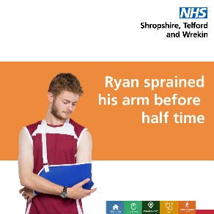 | Your local #MinorInjuryUnit (MIU) can help you get the treatment you need, avoiding the long wait times in A&E ⏰  Find out which non-life-threatening issues #MIUs can help with here ➡ https://shorturl.at/cDeeA  #ThinkWhichService #NHSSTW #NHS #Winter#MinorInjuries #MinorInjuryUnit | Your local #MinorInjuryUnit (MIU) can help you get the treatment you need, avoiding the long wait times in A&E ⏰  MIUs can help with non-life-threatening issues such as:  ✅ Burns and scalds  ✅ Sprains and strains  ✅ Minor fractures  ✅ Wounds needing stitches  ✅ Minor head injuries  For more information visit ➡️️ www.thinkwhichservice.co.uk  #ThinkWhichService #NHSSTW #NHS #Winter #MIU #MinorInjuries #MinorInjuryUnit | Your local #MinorInjuryUnit (MIU) can help you get the treatment you need, avoiding the long wait times in A&E ⏰  MIUs can help with non-life-threatening issues such as:  ✅ Burns and scalds  ✅ Sprains and strains  ✅ Minor fractures  ✅ Wounds needing stitches  ✅ Minor head injuries  #ThinkWhichService #NHSSTW #NHS #Winter #MIU #MinorInjuries #MinorInjuryUnit
5:05PM | Think Which Service Static Image MIU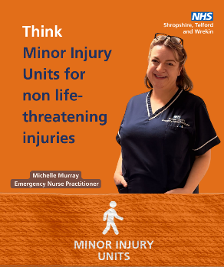 | If you have a minor injury that isn’t life-threatening, head to your closest #MinorInjuryUnit for urgent treatment or advice, without the long A&E wait times ⏰  ➡️️ www.thinkwhichservice.co.uk  #ThinkWhichService #NHSSTW #NHS #Winter #MIU #MinorInjuries | "Think Which Service" for fast, effective care! If you have a minor injury that isn’t life-threatening, visit your closest #MinorInjuryUnit, without the long A&E wait times ⏰  For more information visit ➡️️ www.thinkwhichservice.co.uk  #ThinkWhichService #NHSSTW #NHS #Winter #MIU #MinorInjuries | "Think Which Service" for fast, effective care! If you have a minor injury that isn’t life-threatening, visit your closest #MinorInjuryUnit, without the long A&E wait times ⏰  For more information visit ➡️️ www.thinkwhichservice.co.uk  #ThinkWhichService #NHSSTW #NHS #Winter #MIU #MinorInjuries

Tuesday, 12 November 2024 – A&E / 999
Time | Image | X (Twitter) copy | Facebook / LinkedIn copy | Instagram
9:05 AM | Think Which Service Video A&E Signposting  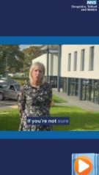 | Vanessa Whatley, Chief Nursing Officer, discusses what to do when you're feeling unwell or facing an emergency.  Getting the right help is essential.  For more information visit ➡️️ www.thinkwhichservice.co.uk  #ThinkWhichService #NHS #NHSSTW #999 #A&E | Vanessa Whatley, Chief Nursing Officer, discusses what to do when you're feeling unwell or facing an emergency.  🤔 Think NHS 111: Unsure what to do? Visit NHS 111 online or call 111 for guidance.  💊 Think Pharmacy: Local pharmacists can help with over-the-counter medications for issues like sore throats and skin rashes.  🏥 Think Minor Injury Units: Our Minor Injury Units in Bridgnorth, Ludlow, Oswestry, and Whitchurch are here for urgent but non-life-threatening needs, like sprains and minor burns.  🚑 Think Which Service: For urgent care, you have options! Think NHS 111, Minor Injury Units, and Pharmacy.  For more information visit ➡️️ www.thinkwhichservice.co.uk  #ThinkWhichService #NHS #NHSSTW #999 #A&E | Vanessa Whatley, Chief Nursing Officer, discusses what to do when you're feeling unwell or facing an emergency.  🤔 Think NHS 111: Unsure what to do? Visit NHS 111 online or call 111 for guidance.  💊 Think Pharmacy: Local pharmacists can help with over-the-counter medications for issues like sore throats and skin rashes.  🏥 Think Minor Injury Units: Our Minor Injury Units in Bridgnorth, Ludlow, Oswestry, and Whitchurch are here for urgent but non-life-threatening needs, like sprains and minor burns.  🚑 Think Which Service: For urgent care, you have options! Think NHS 111, Minor Injury Units, and Pharmacy.  #ThinkWhichService #NHS #NHSSTW #999 #A&E
1:05 PM | Think Which Service Static Image 999  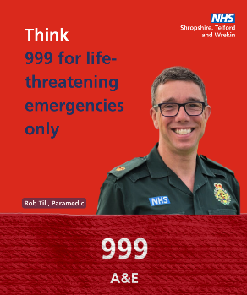 | ☎ Please only call #999 for life-threatening emergencies  🤔 Think #NHS111 online or by phone  💊 Think #Pharmacy for over-the-counter medications  🏥 Think #MinorInjuryUnit for minor injuries that are not life-threatening  #ThinkWhichService #NHS #NHSSTW #A&E | Please only call 999 for life-threatening emergencies.  Think NHS 111 online or by phone  💊 Think Pharmacy first for over-the-counter medications  Think Minor Injury Unit for minor injuries that are not life-threatening.  For more information visit ➡️️ www.thinkwhichservice.co.uk  #ThinkWhichService #NHS #NHSSTW #999 #A&E | Please only call 999 for life-threatening emergencies.  Think NHS 111 online or by phone  💊 Think Pharmacy first for over-the-counter medications  Think Minor Injury Unit for minor injuries that are not life-threatening.  #ThinkWhichService #NHS #NHSSTW #999 #A&E
5:05 PM | Think Which Service Video Hospital Discharge  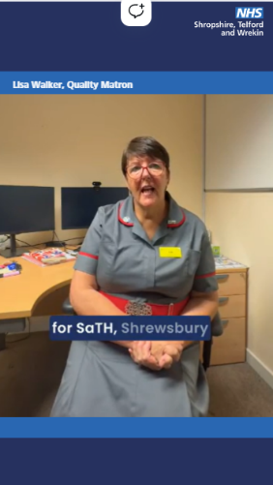 | Lisa Walker, Quality Matron, explains why it’s important for patients to return home from hospital as soon as they're ready, where they can recover in comfort 🏡  #ThinkWhichService #NHS #HospitalDischarge #NHSSTW | Lisa Walker, Quality Matron, explains why it’s important for patients to return home from hospital as soon as they're ready, where they can recover in comfort 🏡  By helping your loved ones get home as soon as they’re ready, you’re not only supporting their recovery but also helping the NHS by freeing up a bed for someone in need of care.  #ThinkWhichService #NHS #HospitalDischarge #NHSSTW | Lisa Walker, Quality Matron, explains why it’s important for patients to return home from hospital as soon as they're ready, where they can recover in comfort 🏡  By helping your loved ones get home as soon as they’re ready, you’re not only supporting their recovery but also helping the NHS by freeing up a bed for someone in need of care.  #ThinkWhichService #NHS #HospitalDischarge #NHSSTW

