SOCIAL MEDIA FOR THE OPEN UP CAMPAIGN TO PREVENT LONELINESS
Image | X | Facebook / LinkedIn
Lucas Static - Parents  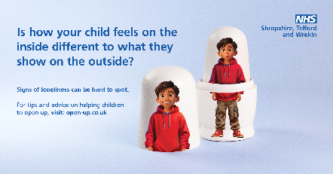 | Signs of #loneliness can be hard to spot as young people struggle to #OpenUp about how they’re feeling 😔  Find out more about the signs of loneliness and how you can help a child visit ➡️ open-up.co.uk | Signs of #loneliness can be hard to spot as young people struggle to #OpenUp about how they’re feeling 😔  Find out more about the signs of loneliness and how you can help a child visit ➡️ open-up.co.uk
Zara Static - Parents  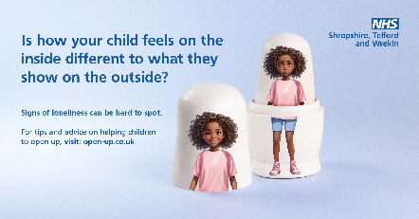 | 1 in 9 young people sometimes feel lonely. Signs of #loneliness can be hard to spot 😕  Find out more about the signs of loneliness and how you can help a child #OpenUp ➡️ open-up.co.uk | 1 in 9 young people sometimes feel lonely. Signs of #loneliness can be hard to spot 😕  Find out more about the signs of loneliness and how you can help a child #OpenUp ➡️ open-up.co.uk
Sophie Static - Parents  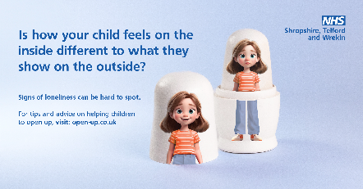 | A child may appear happy on the outside 😃 when, on the inside, they feel lonely 😟  Find out more about the signs of #loneliness and how you can help a child #OpenUp ➡️ open-up.co.uk | A child may appear happy on the outside 😃 when, on the inside, they feel lonely 😟  Find out more about the signs of #loneliness and how you can help a child #OpenUp ➡️ open-up.co.uk
William Static - Parents  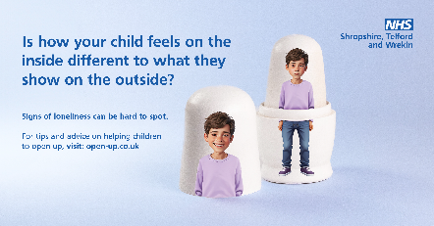 | Signs of #loneliness can be hard to spot as young people struggle to #OpenUp about how they’re feeling.  Signs of loneliness can include:  😔Lack of social connection  🥺Low mood and lack of interest  Find out how to spot the signs of loneliness in children ➡️ open-up.co.uk | Signs of #loneliness can be hard to spot as young people struggle to #OpenUp about how they’re feeling.  Signs of loneliness can include:  😔Lack of social connection  🥺Low mood and lack of interest  Find out how to spot the signs of loneliness in children ➡️ open-up.co.uk
Sophie Video - Parents  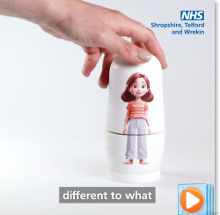 | It's normal for your child to feel lonely sometimes 😣  But there are lots of ways you can help your child tackle loneliness and encourage connection and well-being: ➡️ open-up.co.uk | It's normal for your child to feel lonely sometimes 😣  But there are lots of ways you can help your child tackle loneliness and encourage connection and well-being: ➡️ open-up.co.uk
Lucas Video - Parents  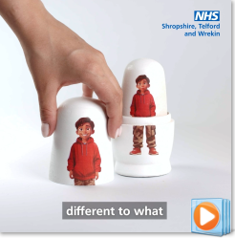 | It can be hard to talk about feeling lonely, and children and young people might not want to say that they don’t have friends or feel left out 👪  Find out more about the signs of loneliness and how you can help a child visit ➡️ open-up.co.uk | It can be hard to talk about feeling lonely, and children and young people might not want to say that they don’t have friends or feel left out 👪  Find out more about the signs of loneliness and how you can help a child visit ➡️ open-up.co.uk
Zara Video - Parents  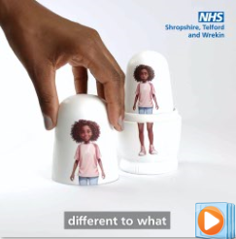 | A child choosing to be by themselves or enjoying their own company is different to loneliness.  ❗ It’s important to know what to look out for and where to go to seek help. Find out more ➡️ open-up.co.uk | A child choosing to be by themselves or enjoying their own company is different to loneliness.  ❗ It’s important to know what to look out for and where to go to seek help. Find out more ➡️ open-up.co.uk
William Video – Parents  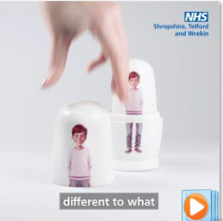 | A child may appear happy on the outside 😃 when, on the inside, they feel lonely 😟  Find out more about the signs of loneliness and how you can help a child open up ➡️ open-up.co.uk | A child may appear happy on the outside 😃 when, on the inside, they feel lonely 😟  Find out more about the signs of loneliness and how you can help a child open up ➡️ open-up.co.uk

