New 'Open Up' Campaign to Tackle Loneliness in Children
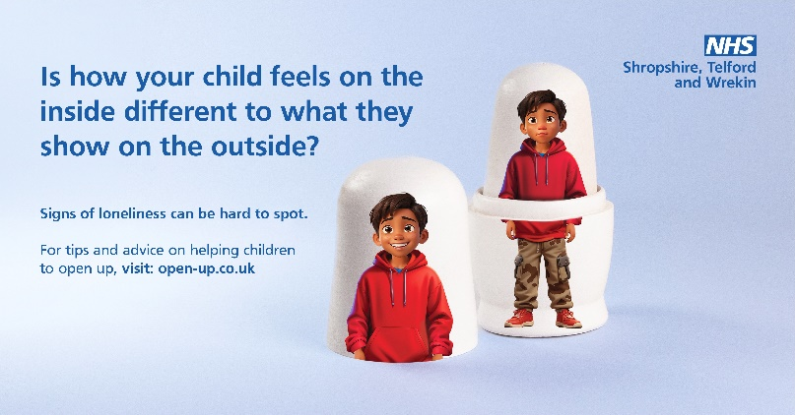
To coincide with Loneliness Awareness Week (10-16 June), NHS Shropshire, Telford and Wrekin has launched the 'Open Up' campaign aimed at addressing the issue of loneliness among children in the region.
The ‘Open Up’ campaign highlights the growing concern of loneliness in children and young people and that signs can be hard to spot. The campaign aims to empower parents and carers (of children aged 7- 13), and children (aged 11-13) with practical tools and support to prevent loneliness, encouraging children to open up to a trusted adult about how they are feeling.

This integrated campaign has been developed in partnership with the local NHS and both local authorities in Shropshire, Telford and Wrekin, and will run across a range of channels including out-of-home advertising, social media, radio, and media.

For tips and advice on how to prevent loneliness, visit: www.open-up.co.uk.

